ANNEX S: Proposed Focal Village Clusters in each Trial Landscape

Trial Landscape 1:

Sites recommended by the Divisional Secretariats and/or Departments of Wildlife or Forest Conservation, and included in the socio-economic survey
Possible activity site | Interviews held for collection of Socio-economic data | Sampling plots surveyed for the rapid biodiversity survey | Possible major activities identified
- Keeriyagaswewa-Kaluebe-Mahadivulwewa tank system (Kekirawa DSD) | Kaluebe | - Kaluebe scrub forest  - Kaluebe riverine forest  - Mahadivulweva homegardens  - Mahadivulweva deciduous forest  - Mahadivulweva tank bund | - Agricultural interventions  - Forestry interventions  - Village fencing  - Eeco-tourism interventions with ongoing cultural/archeological tourism
- Wannamkulama & catchment area of Nachchadoova tank (Thirappane DSD) | Wannamkulama | - Wannamkulama homegardens  - Wannamkulama tank bund | - Agricultural interventions  - Forestry interventions
- Kirindegama-Katupotha-Manankulama-Maradankalla Cascade (Mihintale DSD) | Maradankalla | - Maradankalla tank bund  - Manakkulama tank bund  - Kirindegama tank catchment forest  - Mihintale Sanctuary Karadikulama tank bund  - Anuradhapura Sanctuary scrub forest  - Anuradhapura Sanc Kaludiyapokuna rock outcrop forest | - Agricultural interventions  - Forestry interventions  - Village/cascade based agro/eco-tourism interventions  - Tourism promotion with existing pottery industry

Sites suggested by Divisional Secretariats during the local inception workshop, that have not been visited yet
Possible activity site | Interviews held for collection of Socio-economic data | Sampling plots surveyed for the rapid biodiversity survey | Major activities identified
- Kele Puliyankulama (Kekirawa DSD) | None | None | To be investigated
- Pahala Ambathale (Thirappane DSD) | None | None | To be investigated

Potential activity sites identified for project activities during the rapid biodiversity survey
Possible activity site | Interviews held for collection of Socio-economic data | Sampling plots surveyed for the rapid biodiversity survey | Major activities identified
- Eru wewa (Thirappane DSD) | None | Eru Wewa | - Elephant-viewing based tourism promotion  - Forestry interventions  - Declaration as a new protected area
- Manankattiya wewa (Thirappane DSD) | None | Manankattiya Wewa

Additional sites in Trial Landscape 1 surveyed during the rapid biodiversity survey to document the biodiversity within proposed elephant corridors
Latitude | Longitude | Description of the locality
8.262573 | 80.565107 | Elephant corridor 1 (Hurulu-Mahakanadara) Uttimaduwa scrub forest
8.18842 | 80.67813 | Elephant corridor 1 (Hurulu-Mahakanadara) Yakalla scrubland
8.383212 | 80.595485 | Elephant corridor 2 (Hurulu-Naachchadoova) Seeppukulama tank bund
8.330822 | 80.662065 | Elephant corridor 2 (Hurulu-Naachchadoova) Upuldeniya deciduous forest

Additional sites in Trial Landscape 1 surveyed during the rapid biodiversity survey to investigate the existing range and current status of Labeo lankae, the range-restricted freshwater fish
Latitude | Longitude |  | Description of the locality
8.216256 |  | 80.648065 |  | L. lankae survey - Manankattiya anicut
8.309278 |  | 80.539297 |  | L. lankae survey - Maradankalla tank
8.398694 |  | 80.405944 |  | L. lankae survey - Malwathy Oya at Galpalama
8.448411 |  | 80.512902 |  | L. lankae survey - Weli Oya at Nabadagasveva
8.449797 |  | 80.514018 |  | L. lankae survey - Weli Oya at Nabadagasveva abandoned paddy
Figure 1. Possible project activity sites in Trial Landscape 1 being mapped as clusters of Grama Niladhari Divisions (GNDs). Please see Annex 1 for the total list of all GNDs in Trial Landscape 1.
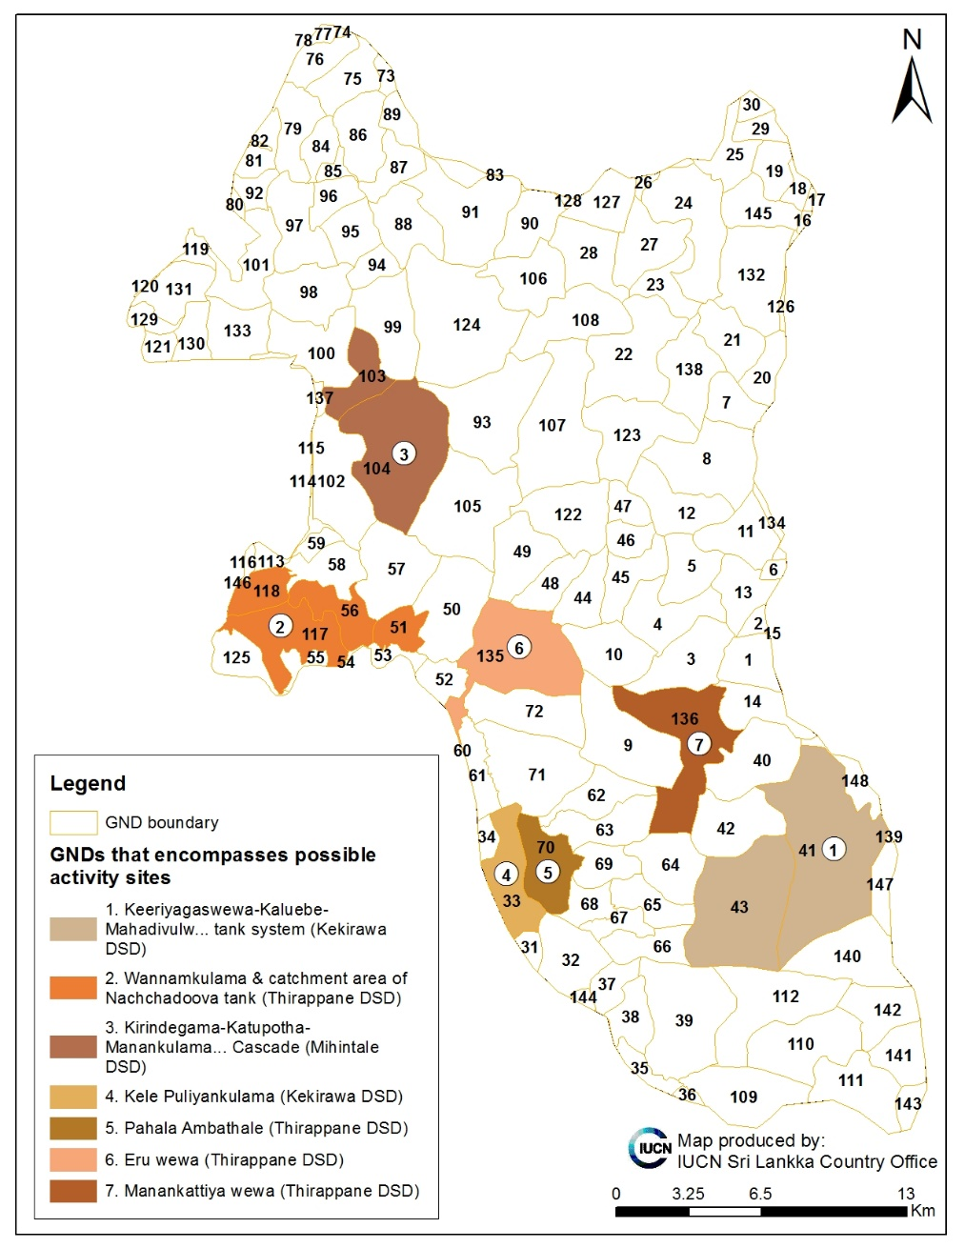

Trial Landscape 2:

Sites recommended by the Divisional Secretariats and/or Departments of Wildlife or Forest Conservation, and included in the socio-economic survey
Possible activity site | Interviews held for collection of Socio-economic data | Sampling plots surveyed for the rapid biodiversity survey | Major activities identified
- Parayanalankulam- Ganeshapuram-Kannati-Thampane veedi- Neeliyamote | Ganeshapuram | None | - Agricultural interventions  - Forestry interventions  - Village fencing
- Beehidia Farm | New Beehidiya Farm | - New Beehidia Farm  - Forest in between Beehidia Farm  - Old Beehidia Farm | - Agricultural interventions  - Forestry interventions  - Possible eco-tourism interventions in old Beehidia farm (along Malwathu Oya)  - Village fencing
- Chemmantheevu - Collarsirikkulam | - Chemmantheevu  - Collarsirikkulam | - Chemmantheevu homegardens  - Kollarsirikkulam tank bund | - Forestry interventions  - Catchment restoration  - Agricultural intervention  - Avi-tourism interventions
- Aalankulama | Aalankulama | - Alamkuluma tank bund | - Forestry interventions  - Catchment restoration  - Agricultural intervention  - Alternatives for Palavu paddy cultivation*
- Kuruvil | Kuruvil | - Giant's tank catchment forest  - Giant's tank catchment grassland | - Forestry interventions  - Catchment restoration  - Agricultural intervention  - Catchment restoration  - Avi-tourism interventions  - Alternatives for Palavu vegetable cultivation*
* “pulavu” is a traditional system of agriculture within the drying tank bed during the “Yala” (which is usually very dry in Mannar) season.

Potential activity sites identified for project activities during the rapid biodiversity survey
Possible activity site | Interviews held for collection of Socio-economic data | Sampling plots surveyed for the rapid biodiversity survey | Major activities identified
- Periyamurippu-Punchikulama | None | None | - Village fencing + to be investigated

Additional sites in Trial Landscape 2 surveyed during the rapid biodiversity survey to document the biodiversity within proposed elephant corridors
Latitude | Longitude | Description of the locality
8.747766 | 80.192724 | Elephant corridor 3 Parayanalankulam deciduous forest
8.783571 | 80.134767 | Elephant corridor 3 Parayanalankulam riverine forest

Additional sites in Trial Landscape 2 surveyed during the rapid biodiversity survey to investigate the existing range and current status of Labeo lankae, the range-restricted freshwater fish
Latitude | Longitude |  | Description of the locality
8.509397 |  | 80.422494 | L. lankae survey - Kanadara oya at Tulavelliya
8.542306 |  | 80.419324 | L. lankae survey - Puleliya tank
 |  |  | L. lankae survey - Malwathy Oya at Beehidiya farm
8.799501 |  | 80.015328 | L. lankae survey - M oya at Kompansalintakulum
 |  |  | L. lankae survey - M oya at Tantirimale
8.751411 |  | 80.163367 | L. lankae survey - M oya at Parayanalankulam
8.74061 |  | 80.181845 | L. lankae survey - Tekkama anicut

Figure 2. Possible project activity sites in Trial Landscape 1 being mapped as clusters of Grama Niladhari Divisions (GNDs). Please see Annex 2 for the total list of all GNDs in Trial Landscape 2.
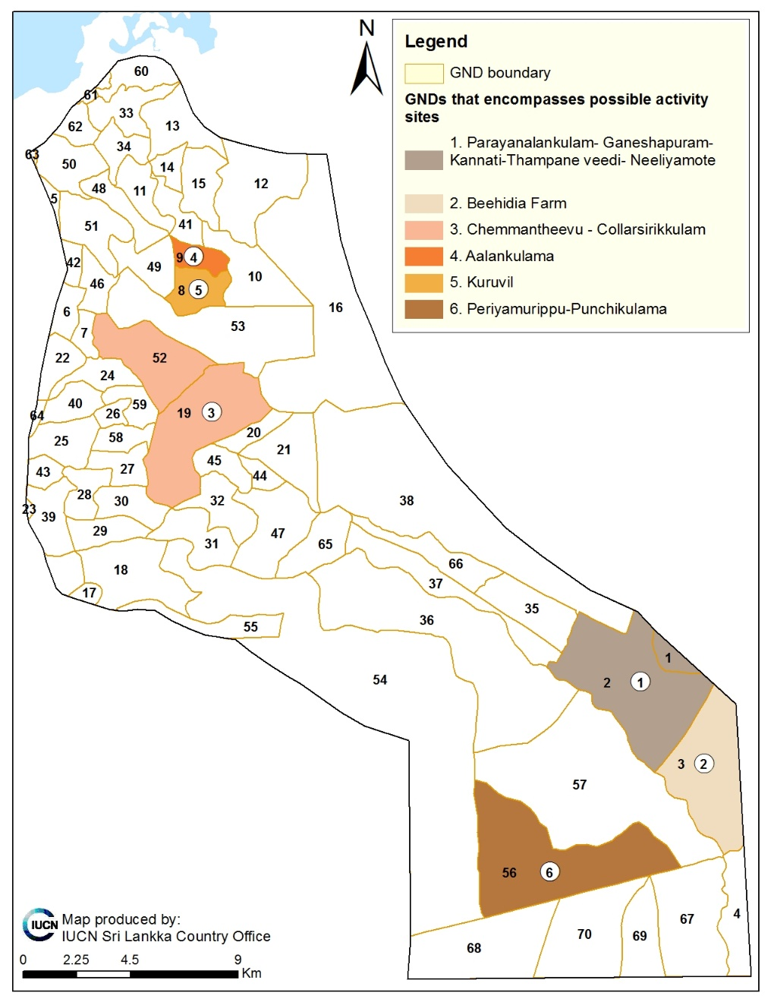

Trial Landscape 3:

Sites recommended by the Divisional Secretariats and/or Departments of Wildlife or Forest Conservation, and included in the socio-economic survey

Possible activity site  (please refer to clusters of GNDs in the map 3) | Interviews held for collection of Socio-economic data | Sampling plots surveyed for the rapid biodiversity survey | Major activities identified
- Vankalai | Vankalai (Thomaspuri) | - Vankalei coastal scrubland | - Sustainable fisheries management interventions  - Forestry interventions– mangrove restoration
- Arippu | Arippu | - Arippu Dorick coastal scrubland  - Arippu estuarine scrubland  - Achchankulum mangrove | - Agricultural interventions  - Forestry interventions – mangrove restoration  - Estuary, mangrove and coral reef based eco-tourism interventions
- Silavatura/Chilavathurai | Silavatura  Saveriyapuram | - Silavatura Beach  - Silavatura coastal scrubland | - Sustainable fisheries management interventions  - Forestry interventions  - Coral reef based eco-tourism interventions to operate from Arippu
- Kondachchi | Kondachchi | - Kondachchi deciduous forest & villu | - Forestry interventions  - Forest product based livelihood interventions

Figure 3. Possible project activity sites in Trial Landscape 3 being mapped as clusters of Grama Niladhari Divisions (GNDs). Please see Annex 3 for the total list of all GNDs in Trial Landscape 1.
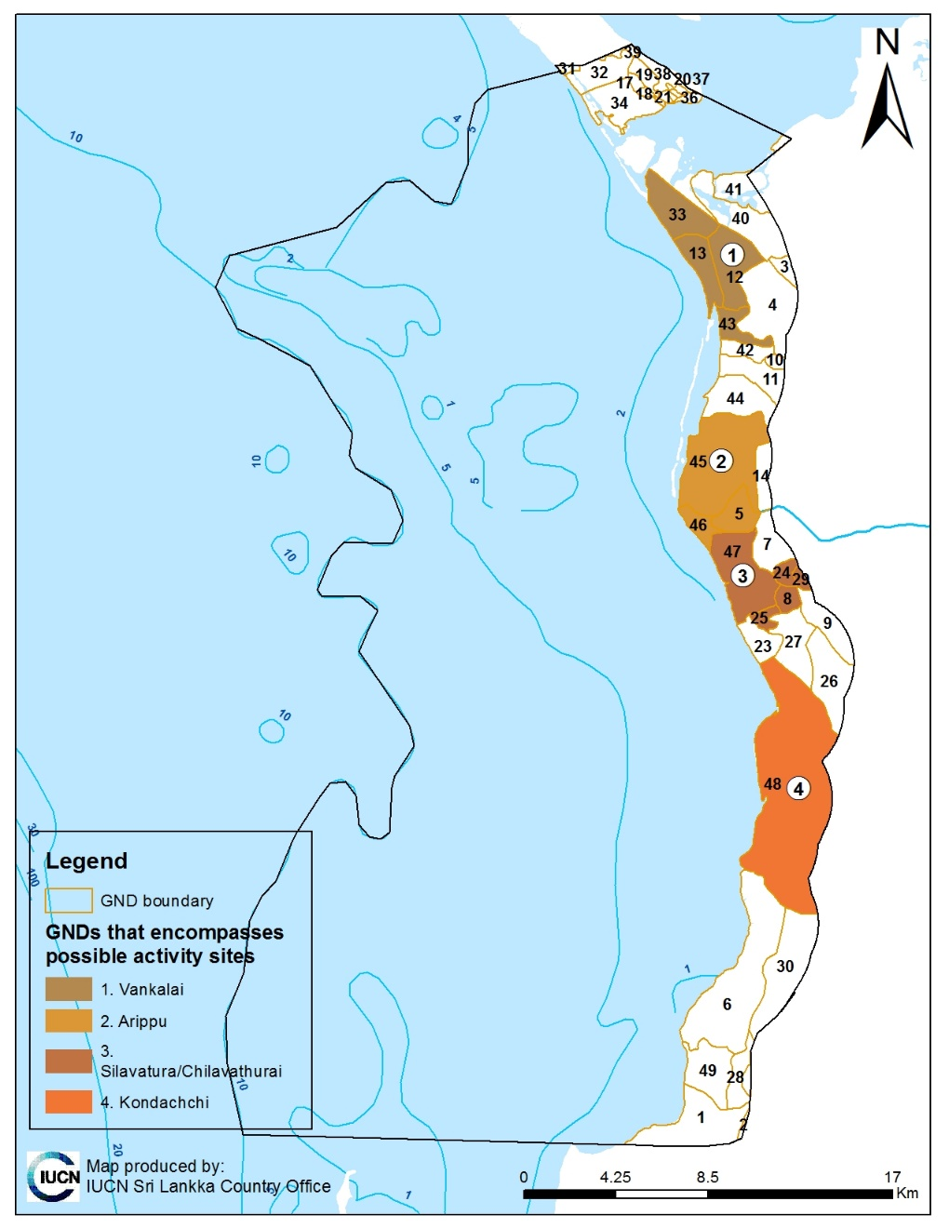
Figure 4. Socio-economic survey locations (numbered from 1 to 14) within each Trial Landscape, corresponding to possible project activity sites. The project landscape and the administrative boundaries of Provinces, Districts and Divisional Secretary Divisions (DSDs) are also provided. DSDs relevant to the project are labelled in black capital letters.
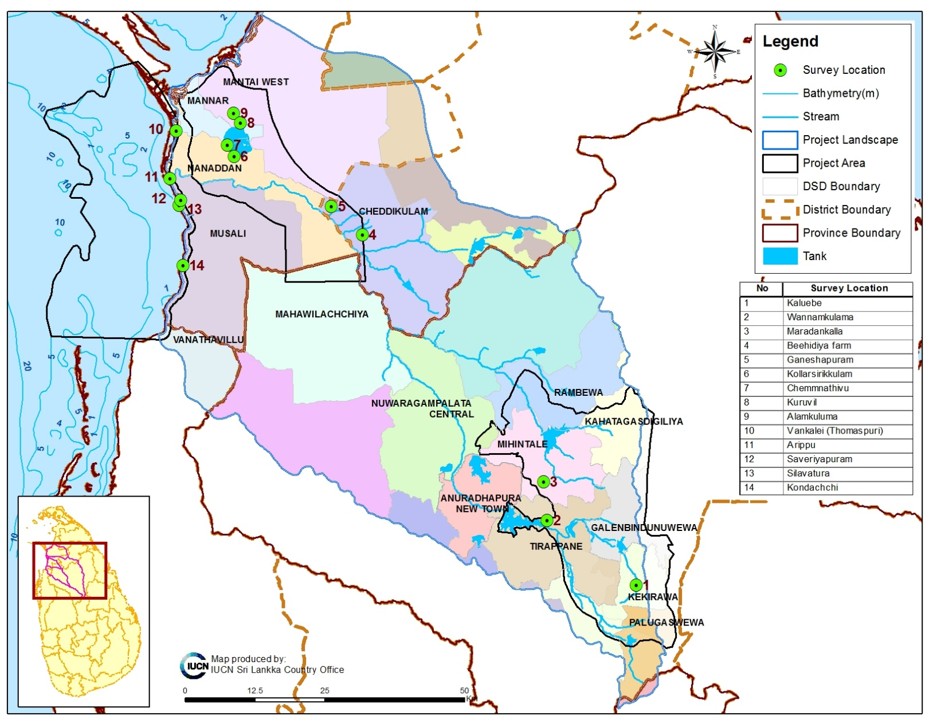
Figure 5. Biodiversity sampling sites (numbered from 1 to 48) within each Trial Landscapes and proposed elephant corridors, including satellite sites for the preliminary survey on the status of Labeo lankae. DSDs relevant to the project are labelled in black capital letters while the protected areas are labelled in blue italicized letters. Biodiversity sampling sites are numbered in the map and described in the Table 1 below.
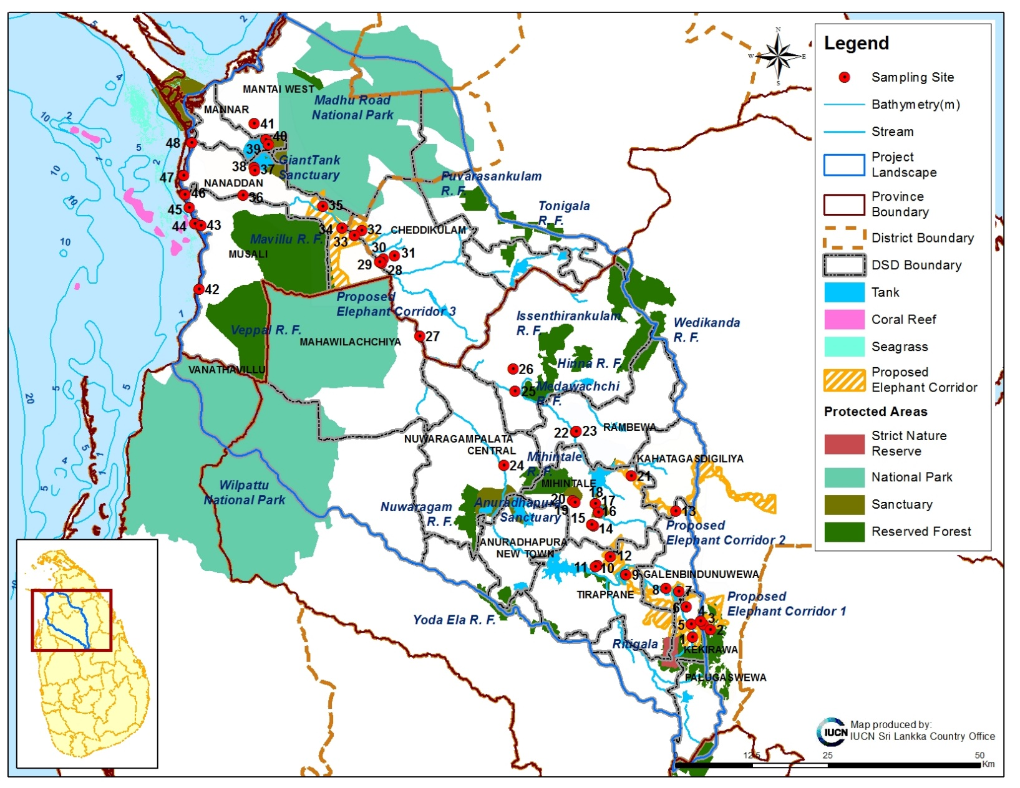

Table 1. Biodiversity sampling sites as numbered in the map in Figure 3.

No | Location
1 | Elephant corridor 1 Yakalla scrubland
2 | Elephant corridor 1 Uttimaduwa scrub forest
3 | Elephant corridor 2 Upuldeniya deciduous forest
4 | Elephant corridor 2 Seeppukulama tank bund
5 | Kaluebe scrub forest
6 | Kaluebe riverine forest
7 | Mahadivulweva homegardens
8 | Mahadivulweva deciduous forest
9 | Mahadivulweva tank bund
10 | Anuradhapura Sanc Kaludiyapokuna rock outcrop forest
11 | Anuradhapura Sanctuary scrub forest
12 | Kirindegama tank catchment forest
13 | Manakkulama tank bund
14 | Mihintale Sanctuary Karadikulama tank bund
15 | L. lankae survey - Manankattiya anicut
16 | L. lankae survey - Maradankalla tank
17 | L. lankae survey - Malwathu Oya at Galpalama
18 | L. lankae survey - Weli Oya at Nabadagasveva
19 | L. lankae survey - Weli Oya at Nabadagasveva abd paddy
20 | Wannamkulama homegardens
21 | Wannamkulama tank bund
22 | Elephant corridor 3 Parayanalankulam deciduous forest
23 | Elephant corridor 3 Parayanalankulam riverine forest
24 | L. lankae survey - Kanadara oya at Tulavelliya
25 | L. lankae survey - Puleliya tank
26 | L. lankae survey - M oya at Kompansalintakulum
27 | L. lankae survey - M oya at Parayanalankulam
28 | L. lankae survey - Tekkama anicut
29 | Beehidiya farm deciduous forest
30 | New Beehidiya farm homegardens
31 | Old Beehidiya farm homegardens
32 | Giant's tank catchemnt grassland
33 | Giant's tank catchment forest
34 | Alamkuluma tank bund
35 | Chemmantivu homegardens
36 | Kollarsirikkulam tank bund
37 | Arippu Dorick coastal scrubland
38 | Arippu estuarine scrubland
39 | Achchankulum mangrove
40 | Silavatura Beach
41 | Silavatura coastal scrubland
42 | Maradankalla tank bund
43 | Manankattiya wewa catchment forest
44 | Eru wewa catchment forest
45 | L. lankae survey - Malwathu Oya at Beehidiya farm
46 | Kondachchi deciduous forest and villu
47 | Vankalei coastal scrubland
48 | L. lankae survey - Malwathu Oya at Trantirimale bridge

Figure 6. Results from each Labeo lankae sampling sites for the preliminary survey on the status of Labeo lankae within the project landscape. DSDs relevant to the project are labelled in black capital letters while the protected areas are labelled in blue italicized letters.
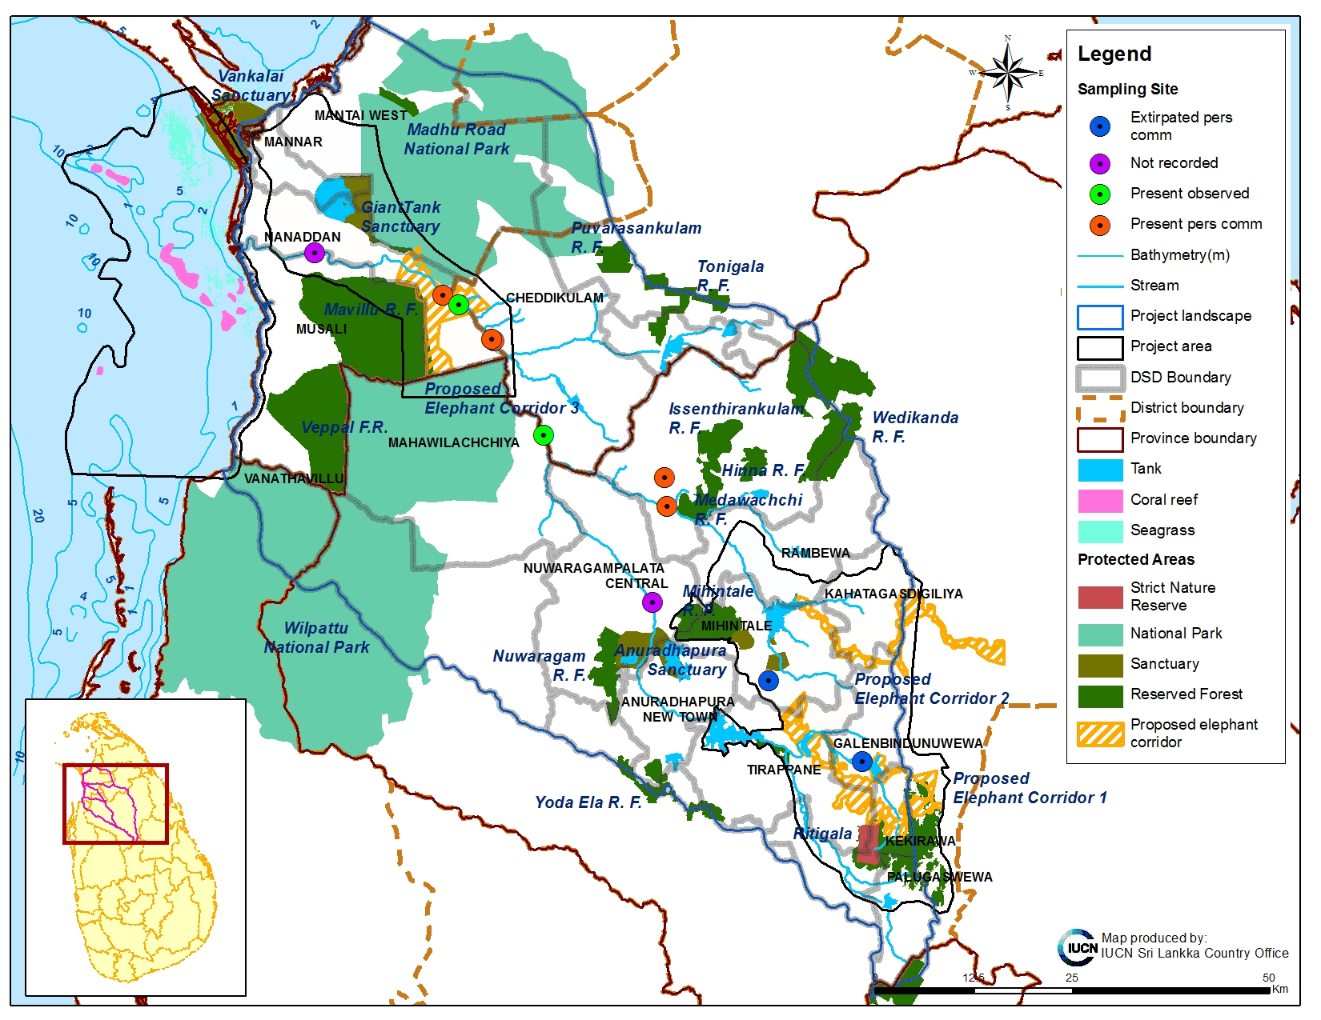

Annex 1. Total list of all GNDs in Trial Landscape 1.
No | PROVINCE_N | DISTRICT_N | DSD_N | GND_N | GND_C | Overlap with Trial Landscape
1 | North Central | Anuradhapura | Galenbidunuwawe | Ihala Galkulama | 187 | Partial
2 | North Central | Anuradhapura | Galenbidunuwawe | Sunanda Mawatha | 191 | Partial
3 | North Central | Anuradhapura | Galenbidunuwawe | Muriyakadawala | 181 | Complete
4 | North Central | Anuradhapura | Galenbidunuwawe | Sivalakulama | 182 | Complete
5 | North Central | Anuradhapura | Galenbidunuwawe | Thammennagama | 160 | Complete
6 | North Central | Anuradhapura | Galenbidunuwawe | Ilukbadayagama | 164 | Partial
7 | North Central | Anuradhapura | Galenbidunuwawe | Konwewa | 156 | Partial
8 | North Central | Anuradhapura | Galenbidunuwawe | Upuldeniya | 155 | Partial
9 | North Central | Anuradhapura | Galenbidunuwawe | Wannamkulama | 185 | Complete
10 | North Central | Anuradhapura | Galenbidunuwawe | Galwaduwagama | 183 | Complete
11 | North Central | Anuradhapura | Galenbidunuwawe | Mailagaswewa | 159 | Complete
12 | North Central | Anuradhapura | Galenbidunuwawe | Himbutugollewa | 157 | Complete
13 | North Central | Anuradhapura | Galenbidunuwawe | Kuda Galenbindunuwewa | 161 | Partial
14 | North Central | Anuradhapura | Galenbidunuwawe | Yakalla | 186 | Partial
15 | North Central | Anuradhapura | Galenbidunuwawe | Hurulu Jayapura | 189 | Partial
16 | North Central | Anuradhapura | Kahatagasdigiliya | Kohobagaskada | 220 | Partial
17 | North Central | Anuradhapura | Kahatagasdigiliya | Mahawewa | 221 | Partial
18 | North Central | Anuradhapura | Kahatagasdigiliya | Kahatagadigiriya East | 231 | Partial
19 | North Central | Anuradhapura | Kahatagasdigiliya | Kahatagasdigiriya West | 232 | Partial
20 | North Central | Anuradhapura | Kahatagasdigiliya | Keleniwewa | 227 | Partial
21 | North Central | Anuradhapura | Kahatagasdigiliya | Nelugollakada | 228 | Complete
22 | North Central | Anuradhapura | Kahatagasdigiliya | Nekutunu Wewa | 200 | Complete
23 | North Central | Anuradhapura | Kahatagasdigiliya | Ellawewa | 197 | Complete
24 | North Central | Anuradhapura | Kahatagasdigiliya | Bethkewa - Thulana | 198 | Complete
25 | North Central | Anuradhapura | Kahatagasdigiliya | Kokmaduwa | 201 | Partial
26 | North Central | Anuradhapura | Kahatagasdigiliya | Moragahawela | 202 | Partial
27 | North Central | Anuradhapura | Kahatagasdigiliya | Ranpathwila | 196 | Complete
28 | North Central | Anuradhapura | Kahatagasdigiliya | Mekichchawa | 203 | Complete
29 | North Central | Anuradhapura | Kahatagasdigiliya | Maha Kiribbewa | 233 | Partial
30 | North Central | Anuradhapura | Kahatagasdigiliya | Kurukuragama | 234 | Partial
31 | North Central | Anuradhapura | Kekirawa | Thoruwewa | 614 | Partial
32 | North Central | Anuradhapura | Kekirawa | Maminiyawa | 613 | Partial
33 | North Central | Anuradhapura | Kekirawa | Kelepuliyankulama | 615 | Partial
34 | North Central | Anuradhapura | Kekirawa | Ihala Puliyankulama | 616 | Partial
35 | North Central | Anuradhapura | Kekirawa | Ebulgaswewa | 632 | Partial
36 | North Central | Anuradhapura | Kekirawa | Medawewa | 633 | Partial
37 | North Central | Anuradhapura | Kekirawa | Maminiya Rambewa | 611 | Complete
38 | North Central | Anuradhapura | Kekirawa | Ganewalpola | 610 | Complete
39 | North Central | Anuradhapura | Kekirawa | Heenukkiriyawa | 609 | Complete
40 | North Central | Anuradhapura | Kekirawa | Nawakkulama | 605 | Complete
41 | North Central | Anuradhapura | Kekirawa | Mahadivulwewa | 608 | Complete
42 | North Central | Anuradhapura | Kekirawa | Moragoda | 606 | Complete
43 | North Central | Anuradhapura | Kekirawa | Keeriyagaswewa | 607 | Complete
44 | North Central | Anuradhapura | Thirappane | Kuttikulama | 530 | Complete
45 | North Central | Anuradhapura | Thirappane | Puliyankulama | 531 | Complete
46 | North Central | Anuradhapura | Thirappane | Mawathawewa | 522 | Complete
47 | North Central | Anuradhapura | Thirappane | Periyakulama | 523 | Complete
48 | North Central | Anuradhapura | Thirappane | Parimaduwa | 524 | Complete
49 | North Central | Anuradhapura | Thirappane | Dematawewa | 525 | Complete
50 | North Central | Anuradhapura | Thirappane | Uttimaduwa | 520 | Complete
51 | North Central | Anuradhapura | Thirappane | Wannamkulama | 521 | Complete
52 | North Central | Anuradhapura | Thirappane | Ethungama North | 551 | Partial
53 | North Central | Anuradhapura | Thirappane | Aluth Punchikulama | 534 | Partial
54 | North Central | Anuradhapura | Thirappane | Thirappanegama | 533 | Partial
55 | North Central | Anuradhapura | Thirappane | Sembukulama | 550 | Partial
56 | North Central | Anuradhapura | Thirappane | Gnanikulama | 528 | Complete
57 | North Central | Anuradhapura | Thirappane | Perimiyankulama | 529 | Complete
58 | North Central | Anuradhapura | Thirappane | Galkulama | 526 | Complete
59 | North Central | Anuradhapura | Thirappane | Karuwalagaswewa | 527 | Partial
60 | North Central | Anuradhapura | Thirappane | Manakkulama | 541 | Partial
61 | North Central | Anuradhapura | Thirappane | Pethis Rambewa | 542 | Partial
62 | North Central | Anuradhapura | Thirappane | Kadupagama | 556 | Complete
63 | North Central | Anuradhapura | Thirappane | Labunoruwa | 555 | Complete
64 | North Central | Anuradhapura | Thirappane | Alagollewa | 543 | Complete
65 | North Central | Anuradhapura | Thirappane | Muriyakadawala | 544 | Complete
66 | North Central | Anuradhapura | Thirappane | Uttupitiya | 560 | Complete
67 | North Central | Anuradhapura | Thirappane | Sadapagama | 559 | Complete
68 | North Central | Anuradhapura | Thirappane | Amunichchiya | 558 | Complete
69 | North Central | Anuradhapura | Thirappane | Ihala Ambatale | 545 | Complete
70 | North Central | Anuradhapura | Thirappane | Pahala Abatale | 557 | Complete
71 | North Central | Anuradhapura | Thirappane | Kattamurichchana | 546 | Complete
72 | North Central | Anuradhapura | Thirappane | Meewellewa | 553 | Complete
73 | North Central | Anuradhapura | Rambewa | Diviyaudabendawewa | 103 | Partial
74 | North Central | Anuradhapura | Rambewa | Wahamalgolewa Track 5 | 110 | Partial
75 | North Central | Anuradhapura | Rambewa | Ikirigollewa | 102
76 | North Central | Anuradhapura | Rambewa | Wahamalgollewa | 108 | Partial
77 | North Central | Anuradhapura | Rambewa | Wahamalgollewa Track 3 A | 109 | Partial
78 | North Central | Anuradhapura | Rambewa | Siyabalagaswewa | 107 | Partial
79 | North Central | Anuradhapura | Rambewa | Pallankulama | 99 | Partial
80 | North Central | Anuradhapura | Rambewa | Katupuliyankulama | 112 | Partial
81 | North Central | Anuradhapura | Rambewa | Mahawewa | 114 | Partial
82 | North Central | Anuradhapura | Rambewa | Pandukabayapura | 115 | Partial
83 | North Central | Anuradhapura | Rambewa | Kallanchiya | 89 | Partial
84 | North Central | Anuradhapura | Rambewa | Rabewa | 100 | Complete
85 | North Central | Anuradhapura | Rambewa | Pallankulama | 99 | Complete
86 | North Central | Anuradhapura | Rambewa | Nabadagaswewa | 101 | Complete
87 | North Central | Anuradhapura | Rambewa | Mahakandarawa R.B. Track 2 | 93 | Complete
88 | North Central | Anuradhapura | Rambewa | Mahakandarawa R.B. Track 1 | 94 | Complete
89 | North Central | Anuradhapura | Rambewa | Gonewa | 92 | Partial
90 | North Central | Anuradhapura | Rambewa | Rotawewa | 95 | Complete
91 | North Central | Anuradhapura | Rambewa | Kudagama | 96 | Complete
92 | North Central | Anuradhapura | Rambewa | Sandamalgama | 113 | Partial
93 | North Central | Anuradhapura | Mihintale | Ihalagama | 565 | Complete
94 | North Central | Anuradhapura | Mihintale | Mahakandarawa Track 1 | 583 | Complete
95 | North Central | Anuradhapura | Mihintale | Mahakandarawa Track 2 | 584 | Complete
96 | North Central | Anuradhapura | Mihintale | Mahakandarawa Track 3 | 585 | Complete
97 | North Central | Anuradhapura | Mihintale | Ukkulankulama | 588 | Complete
98 | North Central | Anuradhapura | Mihintale | Maradankulama | 586 | Complete
99 | North Central | Anuradhapura | Mihintale | Bogahayaya | 582 | Complete
100 | North Central | Anuradhapura | Mihintale | Mihintalaya | 577 | Complete
101 | North Central | Anuradhapura | Mihintale | Doramadalawa | 587 | Partial
102 | North Central | Anuradhapura | Mihintale | Wellaragama | 580 | Complete
103 | North Central | Anuradhapura | Mihintale | Namalwewa | 579 | Complete
104 | North Central | Anuradhapura | Mihintale | Maradankalla | 581 | Complete
105 | North Central | Anuradhapura | Mihintale | Kahapathvilagama | 576 | Complete
106 | North Central | Anuradhapura | Mihintale | Seeppukulama | 566 | Complete
107 | North Central | Anuradhapura | Mihintale | Kasamaduwa | 568 | Complete
108 | North Central | Anuradhapura | Mihintale | Thammmennawa | 567 | Complete
109 | North Central | Anuradhapura | Palugaswewa | Horivila | 603 | Partial
110 | North Central | Anuradhapura | Palugaswewa | Senadhiriyagama | 602 | Complete
111 | North Central | Anuradhapura | Palugaswewa | Palugaswewa | 601 | Partial
112 | North Central | Anuradhapura | Palugaswewa | Galapitagala | 604 | Complete
113 | North Central | Anuradhapura | Nuwaragam Palatha East | Kawarakkulama | 275 | Partial
114 | North Central | Anuradhapura | Nuwaragam Palatha East | Nelunkanniya | 278 | Partial
115 | North Central | Anuradhapura | Nuwaragam Palatha East | Thariyankulama | 280 | Partial
116 | North Central | Anuradhapura | Nuwaragam Palatha East | Keerikkulama | 276 | Partial
117 | North Central | Anuradhapura | Nachchadoowa | Nachchadoowa New Town | 536 | Partial
118 | North Central | Anuradhapura | Nachchadoowa | Nachchaduwa | 535 | Partial
119 | North Central | Anuradhapura | Nuwaragam Palatha Central | Mankadawela | 313 | Partial
120 | North Central | Anuradhapura | Nuwaragam Palatha Central | Jayanthi Gramaya | 315 | Partial
121 | North Central | Anuradhapura | Mihintale | Hene Watta | 572 | Partial
122 | North Central | Anuradhapura | Mihintale | Kattaduwagama | 570 | Complete
123 | North Central | Anuradhapura | Mihintale | Katukelliyawa | 569 | Complete
124 | North Central | Anuradhapura | Mihintale | Pothana | 564 | Complete
125 | North Central | Anuradhapura | Nachchadoowa | Palayakulama | 538 | Partial
126 | North Central | Anuradhapura | Kahatagasdigiliya | Divuwewa | 215 | Partial
127 | North Central | Anuradhapura | Kahatagasdigiliya | Samadigama | 204 | Partial
128 | North Central | Anuradhapura | Rambewa | Meemalwewa | 88 | Partial
129 | North Central | Anuradhapura | Nuwaragam Palatha Central | Thanayankulama | 317 | Partial
130 | North Central | Anuradhapura | Mihintale | Kunchikulama | 573 | Partial
131 | North Central | Anuradhapura | Nuwaragam Palatha Central | Theppankulama | 316 | Complete
132 | North Central | Anuradhapura | Kahatagasdigiliya | Diganhalmillewa | 229 | Complete
133 | North Central | Anuradhapura | Mihintale | Kannattiya | 575 | Complete
134 | North Central | Anuradhapura | Galenbidunuwawe | Ihalagama | 163 | Partial
135 | North Central | Anuradhapura | Thirappane | Ethungama South | 552 | Complete
136 | North Central | Anuradhapura | Galenbidunuwawe | Manankattiya | 184 | Complete
137 | North Central | Anuradhapura | Mihintale | Ruwangama | 578 | Partial
138 | North Central | Anuradhapura | Kahatagasdigiliya | Kanadara - Rathmale | 199 | Complete
139 | North Central | Anuradhapura | Palugaswewa | Maha Rambawewa | 599 | Partial
140 | North Central | Anuradhapura | Palugaswewa | Eppawela | 597 | Partial
141 | North Central | Anuradhapura | Palugaswewa | Kuda Rambawewa | 595 | Partial
142 | North Central | Anuradhapura | Palugaswewa | Kumbukwewa | 596 | Partial
143 | North Central | Anuradhapura | Palugaswewa | Habarana | 589 | Partial
144 | North Central | Anuradhapura | Kekirawa | Kollankuttama | 612 | Complete
145 | North Central | Anuradhapura | Kahatagasdigiliya | Maha Messalewa | 230 | Complete
146 | North Central | Anuradhapura | Nuwaragam Palatha East | Suchritagama | 236 | Partial
147 | North Central | Anuradhapura | Palugaswewa | Madawala | 598 | Partial
148 | North Central | Anuradhapura | Galenbidunuwawe | Hurulumeegahapattiya | 188 | Partial

Annex 2. Total list of all GNDs in Trial Landscape 2.
No | PROVINCE_N | DISTRICT_N | DSD_N | GND_N | GND_C | Overlap with Trial Landscape
1 | Northern | Vavuniya | Vengalacheddiculam | Kannaddy | 207C | Partial
2 | Northern | Vavuniya | Vengalacheddiculam | Periyakadu | 207B | Partial
3 | Northern | Vavuniya | Vengalacheddiculam | Andiyapuliyankulam | 207 | Partial
4 | Northern | Vavuniya | Vengalacheddiculam | Christhokulam | 211D | Partial
5 | Northern | Mannar | Mannar Town | Periyanavatkulam | MNR/87 | Partial
6 | Northern | Mannar | Mannar Town | Uyilankulam | MNR/92 | Partial
7 | Northern | Mannar | Mannar Town | Mathoddam | MNR/93 | Complete
8 | Northern | Mannar | Manthai West | Palaiperumalkaddu | MNR/33 | Complete
9 | Northern | Mannar | Manthai West | Vaddakandal | MNR/32 | Complete
10 | Northern | Mannar | Manthai West | Palaiyadiputhukulam | MNR/34 | Complete
11 | Northern | Mannar | Manthai West | Karunkandal | MNR/26 | Complete
12 | Northern | Mannar | Manthai West | Parappukadanthan West | MNR/35 | Partial
13 | Northern | Mannar | Manthai West | Kannady | MNR/28 | Partial
14 | Northern | Mannar | Manthai West | Andakulam | MNR/27 | Complete
15 | Northern | Mannar | Manthai West | Alkaddiveli | MNR/29 | Complete
16 | Northern | Mannar | Manthai West | Parappukadanthan East | MNR/36 | Partial
17 | Northern | Mannar | Musalai | Periyapullachchi Potkerni | MNR/141 | Partial
18 | Northern | Mannar | Musalai | Veppankulam | MNR/140 | Partial
19 | Northern | Mannar | Nanaddan | Chemmantheevu | MNR/117 | Complete
20 | Northern | Mannar | Nanaddan | Murunkan | MNR/118 | Complete
21 | Northern | Mannar | Nanaddan | Cheddiyar Mahankaddai Adampan | MNR/126 | Complete
22 | Northern | Mannar | Nanaddan | Ilahadipiddy | MNR/111 | Partial
23 | Northern | Mannar | Nanaddan | Rasamadhu | MNR/105 | Partial
24 | Northern | Mannar | Nanaddan | Ilantaimoddai | MNR/112 | Complete
25 | Northern | Mannar | Nanaddan | Nanaddan | MNR/107 | Partial
26 | Northern | Mannar | Nanaddan | Aththikkuli | MNR/116 | Complete
27 | Northern | Mannar | Nanaddan | Puttirarkandan | MNR/113 | Complete
28 | Northern | Mannar | Nanaddan | Valkaipaddankandal | MNR/109 | Complete
29 | Northern | Mannar | Nanaddan | Kalimoddai Puliyankulam | MNR/122 | Complete
30 | Northern | Mannar | Nanaddan | Pontheevukandal | MNR/121 | Complete
31 | Northern | Mannar | Nanaddan | Pariyarikandal | MNR/123 | Complete
32 | Northern | Mannar | Nanaddan | Sirukandal | MNR/120 | Complete
33 | Northern | Mannar | Manthai West | Minukkan | MNR/20 | Complete
34 | Northern | Mannar | Manthai West | Nedunkandal | MNR/24 | Complete
35 | Northern | Mannar | Madhu | Maluvarayarkaddayadampan | MNR/128 | Complete
36 | Northern | Mannar | Madhu | Pannavedduvan | MNR/129 | Complete
37 | Northern | Mannar | Madhu | Thekkam | MNR/131 | Complete
38 | Northern | Mannar | Madhu | Madhu | MNR/37 | Partial
39 | Northern | Mannar | Nanaddan | Pallankoddai | MNR/108 | Partial
40 | Northern | Mannar | Nanaddan | Periyakkaddaikadu | MNR/110 | Complete
41 | Northern | Mannar | Manthai West | Karunkandal Vannakulam | MNR/30 | Complete
42 | Northern | Mannar | Mannar Town | Neelasenai | MNR/89 | Partial
43 | Northern | Mannar | Nanaddan | Moddaikadai | MNR/106 | Partial
44 | Northern | Mannar | Nanaddan | Iraddaikulam | MNR/125 | Complete
45 | Northern | Mannar | Nanaddan | Chundikkuli | MNR/119 | Complete
46 | Northern | Mannar | Mannar Town | Vannamoddai | MNR/94 | Complete
47 | Northern | Mannar | Nanaddan | Katkadanthakulam | MNR/124 | Complete
48 | Northern | Mannar | Manthai West | Sornapuri | MNR/25 | Complete
49 | Northern | Mannar | Manthai West | Kaththankulam | MNR/31 | Complete
50 | Northern | Mannar | Manthai West | Adampan | MNR/22 | Complete
51 | Northern | Mannar | Manthai West | Palikuli | MNR/23 | Complete
52 | Northern | Mannar | Mannar Town | Uyirtharayankulam | MNR/95 | Complete
53 | Northern | Mannar | Mannar Town | Parappankandal | MNR/96 | Complete
54 | Northern | Mannar | Musalai | Maruthamadhu | MNR/139 | Partial
55 | Northern | Mannar | Musalai | Sinnapullachchi Potkerni | MNR/142 | Partial
56 | Northern | Mannar | Madhu | Periyamurippu | MNR/133 | Complete
57 | Northern | Mannar | Madhu | Matha Kiramam | MNR/132 | Complete
58 | Northern | Mannar | Nanaddan | Razoolputhuveli | MNR/114 | Complete
59 | Northern | Mannar | Nanaddan | Kanchithalvu | MNR/115 | Complete
60 | Northern | Mannar | Manthai West | Pappamoddai | MNR/18 | Partial
61 | Northern | Mannar | Manthai West | Maligaithidal | MNR/21 | Partial
62 | Northern | Mannar | Manthai West | Veddayarmurrippu | MNR/19 | Partial
63 | Northern | Mannar | Mannar Town | Thiruketheeswaram | MNR/86 | Partial
64 | Northern | Mannar | Nanaddan | Umanagiri | MNR/103 | Partial
65 | Northern | Mannar | Nanaddan | Issaimalaithalvu | MNR/127 | Complete
66 | Northern | Mannar | Madhu | Poomalarnthan | MNR/130 | Complete
67 | North Central | Anuradhapura | Maha Vilachchiya | Dematamalgama | 367 | Partial
68 | North Central | Anuradhapura | Maha Vilachchiya | Mannaram Junction | 365 | Partial
69 | North Central | Anuradhapura | Maha Vilachchiya | Nelumvila | 368 | Partial
70 | North Central | Anuradhapura | Maha Vilachchiya | Sadamaleliya | 369 | Partial

Annex 3. Total list of all GNDs in Trial Landscape 3.
No | PROVINCE_N | DISTRICT_N | DSD_N | GND_N | GND_C | Overlap with Trial Landscape
1 | North Western | Puttalam | Vanathavilluwa | Pukkulama | 634 | Partial
2 | North Western | Puttalam | Vanathavilluwa | Ralmaduwa | 635/2 | Partial
3 | Northern | Mannar | Mannar Town | Kallikaddaikkadu | MNR/90 | Partial
4 | Northern | Mannar | Mannar Town | Puthukamam | MNR/91 | Partial
5 | Northern | Mannar | Musalai | Arippu East | MNR/135 | Complete
6 | Northern | Mannar | Musalai | Karadikkuli | MNR/150 | Complete
7 | Northern | Mannar | Musalai | Poonochchikulam | MNR/138 | Partial
8 | Northern | Mannar | Musalai | Puthuveli | MNR/146 | Complete
9 | Northern | Mannar | Musalai | Ahakkimurippu | MNR/143 | Partial
10 | Northern | Mannar | Nanaddan | Ilahadipiddy | MNR/111 | Partial
11 | Northern | Mannar | Nanaddan | Vanchiankulam | MNR/102 | Partial
12 | Northern | Mannar | Nanaddan | Vankalai East | MNR/99 | Complete
13 | Northern | Mannar | Nanaddan | Vankalai West | MNR/98 | Complete
14 | Northern | Mannar | Nanaddan | Rasamadhu | MNR/105 | Partial
15 | Northern | Mannar | Mannar Town | Uppukulam South | MNR/83 | Complete
16 | Northern | Mannar | Mannar Town | Moor Street | MNR/81 | Complete
17 | Northern | Mannar | Mannar Town | Emil Nagar | MNR/74 | Complete
18 | Northern | Mannar | Mannar Town | Panankaddikoddu West | MNR/76 | Complete
19 | Northern | Mannar | Mannar Town | Savatkaddu | MNR/75 | Complete
20 | Northern | Mannar | Mannar Town | Uppukkulam North | MNR/82 | Partial
21 | Northern | Mannar | Mannar Town | Pettah | MNR/79 | Complete
22 | Northern | Mannar | Mannar Town | Periyakadai | MNR/80 | Complete
23 | Northern | Mannar | Musalai | Chilavathurai | MNR/144 | Complete
24 | Northern | Mannar | Musalai | Pandaraveli | MNR/137 | Partial
25 | Northern | Mannar | Musalai | Severiyarpuram | MNR/145 | Complete
26 | Northern | Mannar | Musalai | Kokkupadayan | MNR/148 | Partial
27 | Northern | Mannar | Musalai | Kollankulam | MNR/147 | Complete
28 | Northern | Mannar | Musalai | Marichchukaddi | MNR/151 | Partial
29 | Northern | Mannar | Musalai | Sinnapullachchi Potkerni | MNR/142 | Partial
30 | Northern | Mannar | Musalai | Palaikuli | MNR/152 | Partial
31 | Northern | Mannar | Mannar Town | Pattithoddam | MNR/71 | Partial
32 | Northern | Mannar | Mannar Town | Eluthur | MNR/72 | Partial
33 | Northern | Mannar | Nanaddan | Vankalai North | MNR/97 | Complete
34 | Northern | Mannar | Mannar Town | South Bar | MNR/73 | Complete
35 | Northern | Mannar | Mannar Town | Panankaddikoddu East | MNR/77 | Complete
36 | Northern | Mannar | Mannar Town | Pallimunai East | MNR/84 | Partial
37 | Northern | Mannar | Mannar Town | Pallimunai West | MNR/85 | Partial
38 | Northern | Mannar | Mannar Town | Sinnakadai | MNR/78 | Partial
39 | Northern | Mannar | Mannar Town | Tharapuram East | MNR/69 | Partial
40 | Northern | Mannar | Mannar Town | Nagathalvu | MNR/88 | Partial
41 | Northern | Mannar | Mannar Town | Thiruketheeswaram | MNR/86 | Partial
42 | Northern | Mannar | Nanaddan | Naruvilikkulam | MNR/101 | Complete
43 | Northern | Mannar | Nanaddan | Thomaspuri | MNR/100 | Complete
44 | Northern | Mannar | Nanaddan | Umanagiri | MNR/103 | Partial
45 | Northern | Mannar | Nanaddan | Achchankulam | MNR/104 | Complete
46 | Northern | Mannar | Musalai | Arippu West | MNR/134 | Complete
47 | Northern | Mannar | Musalai | Methanveli | MNR/136 | Complete
48 | Northern | Mannar | Musalai | Kondachchi | MNR/149 | Partial
49 | Northern | Mannar | Musalai | Mullikkulam | MNR/153 | Complete

